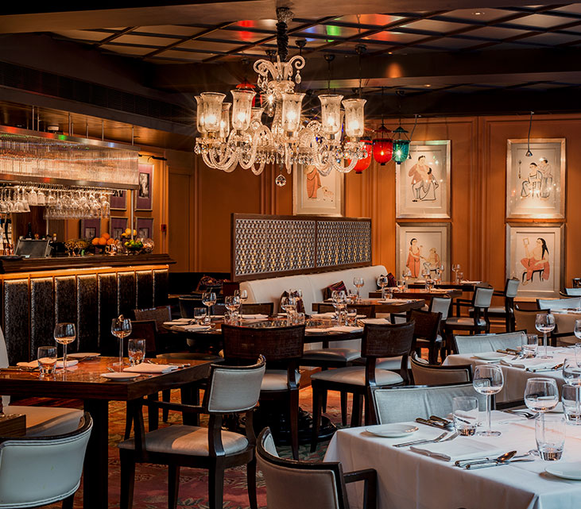

Authored by: Ayan Guha

Capstone Project: The Battle of Neighborhoods

Reinventing Restaurants: A Data Based Approach

How to survive in a COVID-19 pandemic economy?

# Introduction

This project is a part of the IBM Data Science Specialization course where we learned what data scientists go through in real life when working with data. In this project we shall define a business problem, scrape data from the web and with the skills of a data scientist, create a compelling narrative from the data. Our tools for this project will be density-based clustering using K-means algorithm and other machine learning techniques. In this project, we shall provide a step-by-step description of the processes involved starting from defining the business problem, data preparation and the techniques that forge the data to create a final analysis. The project ends with a conclusion section which can be leveraged by business stakeholders to make decisions.

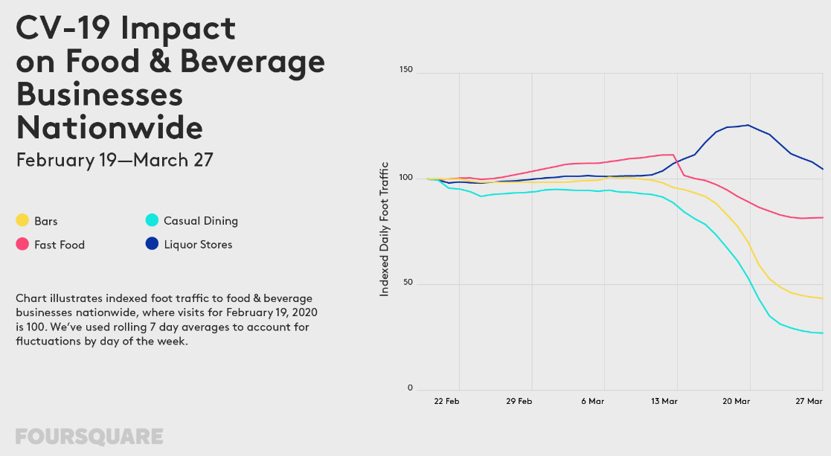

Source: <https://foursquare.com/>

# Business Problem:

In January 2020, a new decade started with a hopeful bang - while a coronavirus (SARS-CoV-2), born from a wet market, started gaining a foothold in China. In next two months, coronavirus pandemic (COVID-19) stretched around the world forcing countries to enforce lockdown measures like stopping air travel and closing borders. In US, a nationwide emergency was declared on March 13 and most states started enforcing stringent lockdown measures. Apart from a tragically large number of human lives being lost, millions of Americans lost their livelihood resulting in the worst economic downturn since the Great Depression. The coronavirus recession - also known as ***Great Lockdown*** - shuttered schools, businesses, and restaurants, delivering the fastest and deepest economic shock in history. Consumer behavior changed drastically since the COVID-19 outbreak began. After an initial rush for groceries and stock piling of necessary supplies, families cloistered themselves in the safety of their homes - online shopping surged as replacement for old fashioned trips to grocery stores. The graph above (compiled by Foursquare) shows the impact of COVID-19 on Food & Beverage Businesses in US. As we can see, Casual Dining industry suffered the most. Nationally, foot traffic to sit-down casual dining restaurants decreased more than 73%, while visits to Quick Service Restaurants (QSR) were only down by 18%. Since QSRs offer drive through and take out, consumers felt more comfortable visiting those establishments. Interestingly, people visiting QSRs are spending less time in those locations. The week ending March 27, had 10% more customers spending less than 15 mins as compared to a month earlier. Majority of the customers (91%) preferred drive through or take-out as compared to dining in. Also, they preferred visiting QSRs closer to their homes than a QSR further away.

***Reading this analysis, reminded me of my friend Mr. Lohanathan (LN), who owns an Indian Restaurant in Austin. Here is how our conversation went:***

***Me:*** *How is your restaurant doing in these troubling times?*

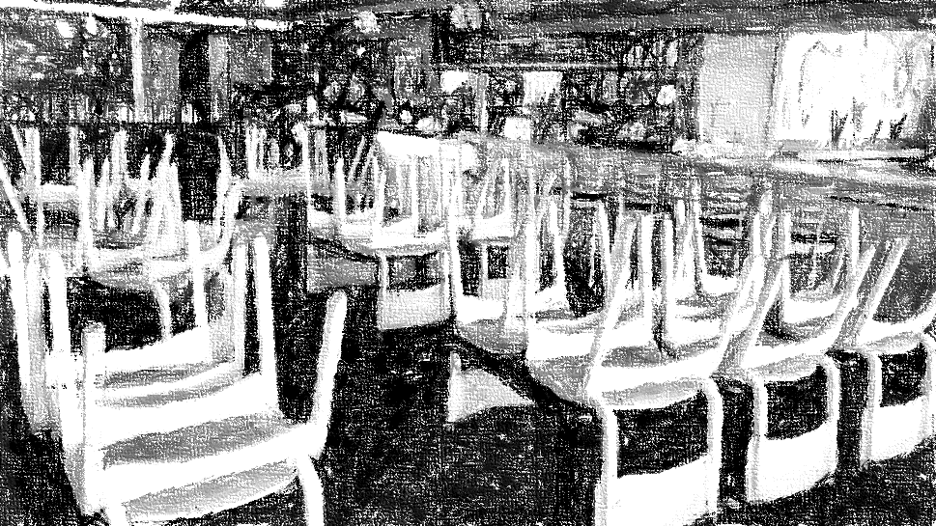

Restaurant during COVID-19 times: Waiting for customers

***LN:*** *I am devastated. Our revenues have dropped more than 90%, we are open only for take-out. But very few customers are entering through the door.*

***Me:*** *Sorry to hear that, maybe you should change your strategy. Remember the phrase “If the mountain will not come to Muhammad, then Muhammad must go to the mountain”*

***LN:*** *I am now confused. What do you mean?*

***Me:*** *If customers will not come to your shop, then the shop must go to the customers. It’s time to take your restaurant mobile. Why not start a food truck?*

***LN:*** *Good idea, but people are off the streets, there is no reason for food trucks to go to familiar lunch spots.*

***Me:*** *What if we go directly to the neighborhoods? Being mobile has another advantage, you can source your supplies further away from the city. With food supply chain severely strained, you can now procure fresh vegetables, poultry, and meat from farms in Austin suburbs.*

***LN:*** *Well, that is an advantage for sure.*

***Me:*** *By traveling to residential areas, you have access to those customers who are self-quarantined but would like Indian food. You can also serve those spots that otherwise encounter difficulty with normal food delivery service.*

***LN:*** *I am sold to this idea, but which neighborhoods should I visit?*

***Me:*** *Let me put on my data scientist hat and help you find out the neighborhoods where your customers live.*

With this background, I was motivated to solve the following business problem statement.

***Which neighborhoods in Austin are profitable for a mobile Indian restaurant to visit?***

Apart from Mr. Lohanathan - a business owner who is looking for creative solutions to save his restaurant, this analysis will also be valuable to the following people:

* ***Business investors***, who are looking for opportunities to invest in mobile food delivery business.
* ***Event organizers***, who can organize block parties in open venues (like a school parking lot) where the invitees can enjoy casual dining while maintaining social distancing guidelines.
* ***City planners***, who can look at possibility of outdoor seating for mobile food vendors in shuttered streets so that citizens can safely practice social distancing during COVID-19 pandemic.
* ***Consumers***, who will be interested in finding out a new feature (namely, access to mobile food delivery) in their neighborhood.

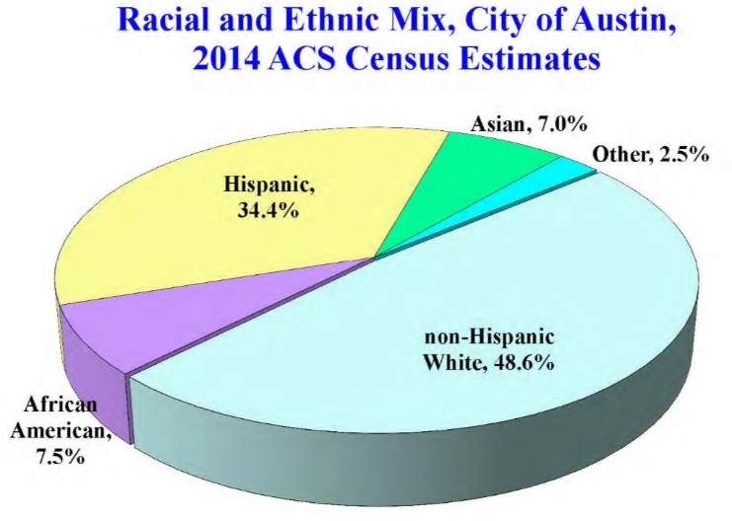*Before starting my data collection, I decided to research on the demographic characteristic of Indian population in Austin.*

# Background research:

<http://www.austintexas.gov/department/about-asian-american-quality-life>

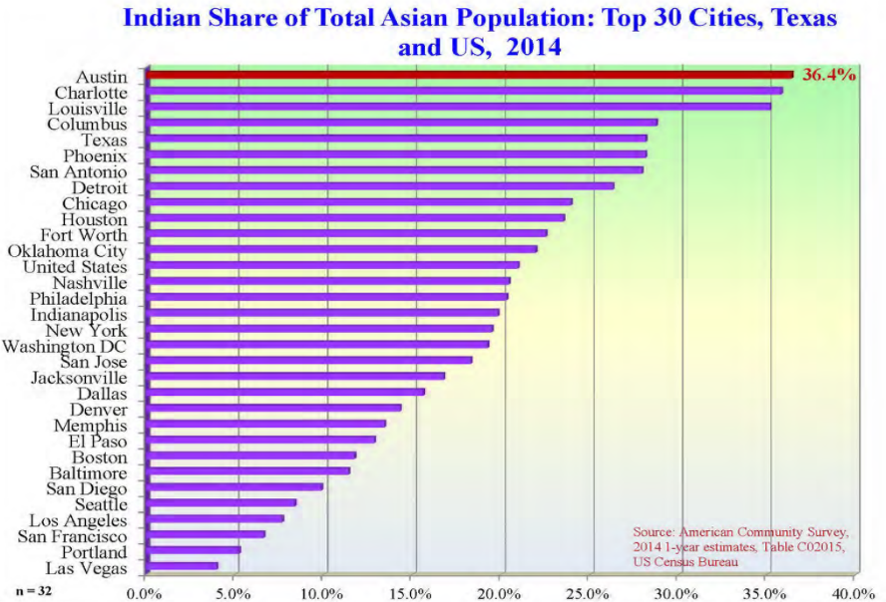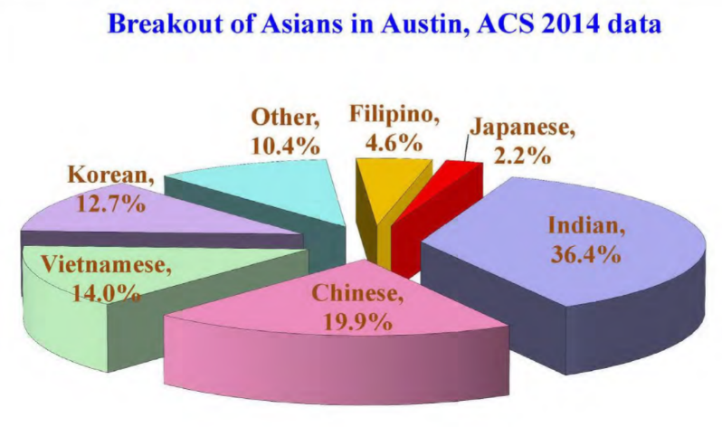 In recent years, Austin has firmly established itself as a destination city for Asian families from a wide range of national backgrounds and ethnicities. Located in the heart of Texas, Austin has recently transformed from a college town to one of the largest, most vibrant cities in the U.S. Asians in Austin are the fastest growing demographic in terms of percentage year-to-year gain and are doubling in total size roughly every 12 years. Austin’s burgeoning knowledge economy is a magnet for highly educated Asians whose Median Family Income (MFI) is the highest among any demographic group in the city. In terms of Asian MFI, Austin ranks the 3rd highest among nation’s 30 largest cities. With many tech companies calling Austin their second home, the city is being called mini “Bay Area” with people moving in from western and eastern states of the U.S. Austin is currently the fastest growing city in the United States with young, recent college graduates and retiring baby boomers constituting majority of the new arrivals. The Asian community in Austin is highly diverse with significant subgroups formed by Indians, Chinese, Vietnamese, Koreans and Filipinos. ***Indians represent roughly 1/3rd of all Asians in Austin and is the fastest growing Asian subgroup***. With 36.4% share of the total Asian population, ***the Indian subgroup ranks first in the nation*** – no other cities among the top 30 cities in the country has a larger Indian share of Total Asian Population.

*With such an encouraging demographic trend, Austin is the perfect city for an Indian mobile restaurant that would cater to its rapidly growing population.*

# Data Section:

The data from this project will be sourced from the following places:

### data.austintexas.gov (<https://data.austintexas.gov/>) :

A data portal that provides easy access to open data and information about the city government.

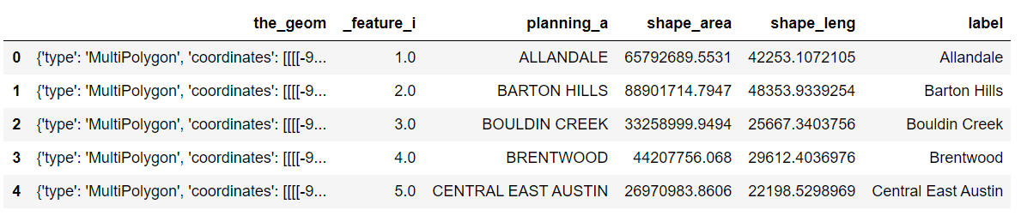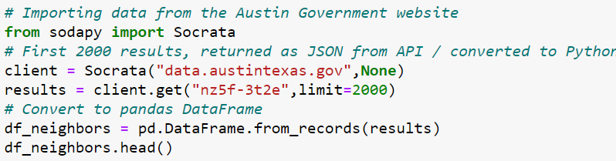This code snippet collects the neighborhood boundaries from the City of Austin website.

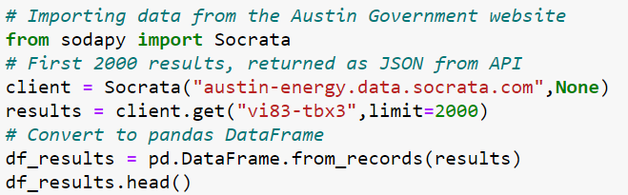

The same portal also provides census tracts along with the demographic data each tract.

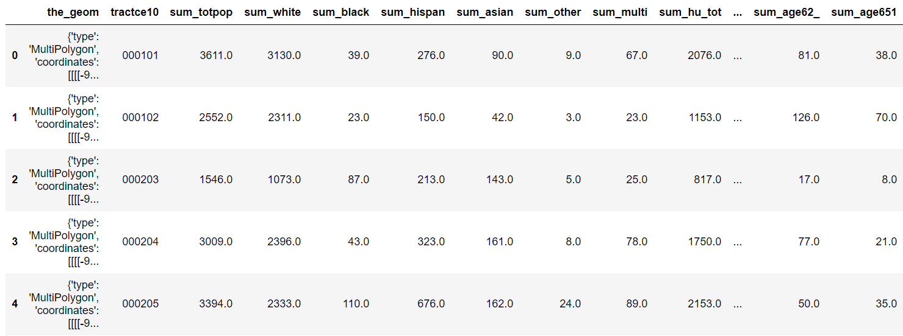

### United States Census Bureau ([<https://www.census.gov/data.html>/](https://data.austintexas.gov/)) :

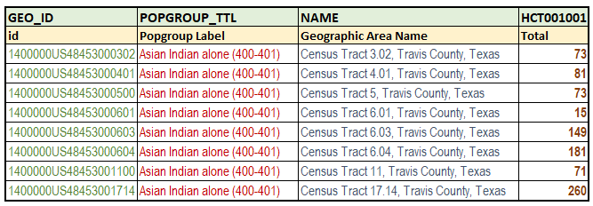The United States Census Bureau is a principal agency of the U.S. Federal Statistical System, responsible for producing data about the American people and economy. A snippet of the data obtained from the Census Bureau providing the population of Indian living in each Census Tract of Travis County.

**From Wikipedia: Travis County** is a [county](https://en.wikipedia.org/wiki/County_(United_States)) in south [central Texas](https://en.wikipedia.org/wiki/Central_Texas). As of the [2010 census](https://en.wikipedia.org/wiki/2010_United_States_Census), the population was 1,024,266; the estimated population in 2019 was 1,273,954.[[1]](https://en.wikipedia.org/wiki/Travis_County,_Texas#cite_note-QF-1) It is the fifth-most populous county in [Texas](https://en.wikipedia.org/wiki/Texas). Its [county seat](https://en.wikipedia.org/wiki/County_seat) is [Austin](https://en.wikipedia.org/wiki/Austin,_Texas),[[2]](https://en.wikipedia.org/wiki/Travis_County,_Texas#cite_note-GR6-2) the capital of Texas. Travis County is part of the Austin-[Round Rock](https://en.wikipedia.org/wiki/Round_Rock,_Texas) [Metropolitan Statistical Area](https://en.wikipedia.org/wiki/Greater_Austin).

### FOURSQUARE ([<https://foursquare.com/>](https://data.austintexas.gov/)) :

An American technology company that provides location platform for several businesses like UBER, TARGET, Twitter, SUBWAY, and many others. In this project, we shall make calls to the Foursquare API to search for venues as well as specific type of venues or restaurants around a given location. With the data available from FOURSQUARE, we shall explore neighborhoods, segment and group them into clusters to find similar neighborhoods in Austin. A density-based clustering algorithm, called K-means shall be used in this project to model the neighborhoods.

# Data Cleaning:

The census data obtained from the City of Austin data portal identifies the census tracts (column “tractce10”) as “object” datatype with 6 digits. The census data obtained from the United States Census Bureau identifies the census tracts (column “Geographic Area Name”) as “Census Tract *. **, Travis County, Texas”. To clean up the dataframe from Census Bureau, the extra strings were removed, and the data type was converted to integer. Similarly, the annoying “0”s in front of census tracts were removed by converting the “tractce10” column (from City of Austin data portal) to integer datatype. Finally, we have the Census Tract column of same type (namely, integer) for both data sets, which is essential for searching, filtering and merging the information from both datasets. Since the datasets didn’t have any “NaN” or “non-standard missing values”, no further cleaning was necessary, apart from dropping columns not needed for our analysis.

# Visualizing Austin Neighborhoods:

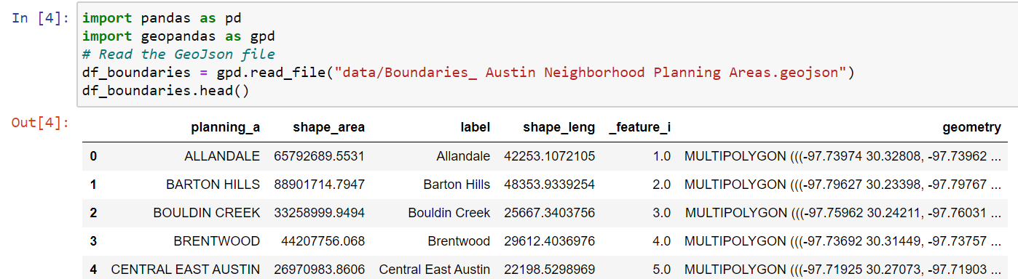Our analysis starts with creating a dataframe (***df_boundaries***) of the boundaries of Austin Neighborhoods. The dataframe was created by reading a GeoJson file obtained from the City of Austin data portal.

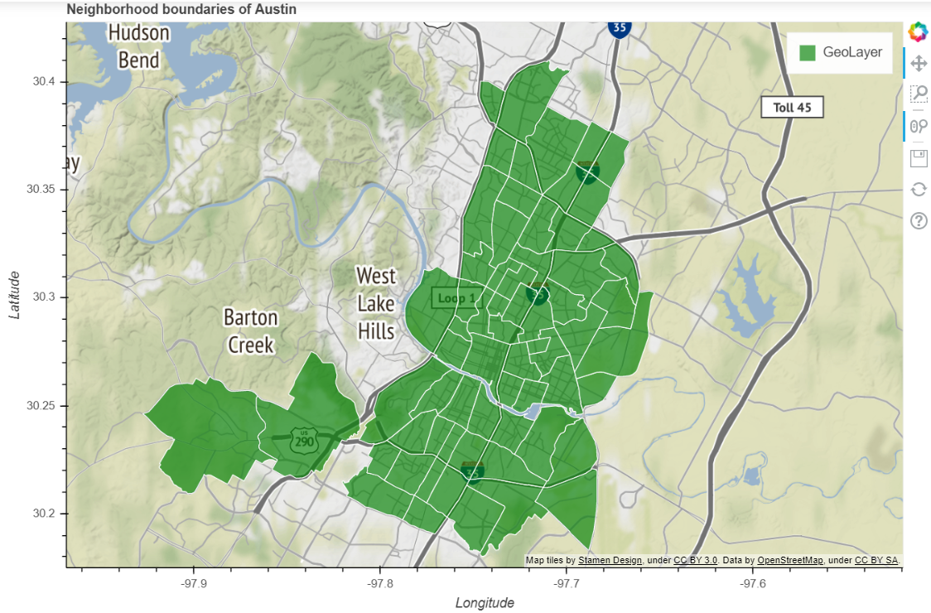

*A visualization of the neighborhood boundaries using Bokeh library*:

Our next steps are: **(a)** calculate the centroid of each boundary

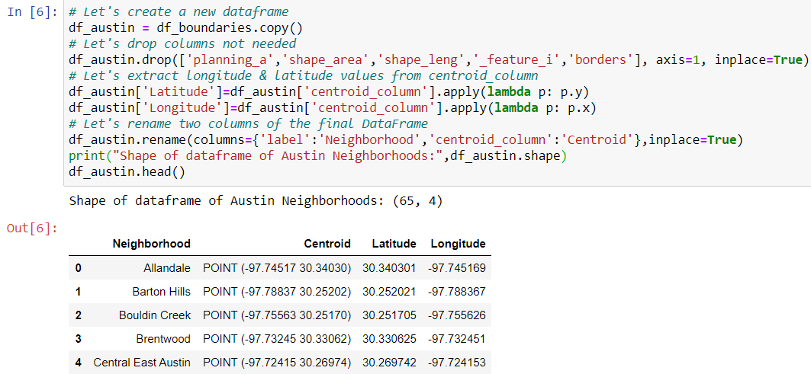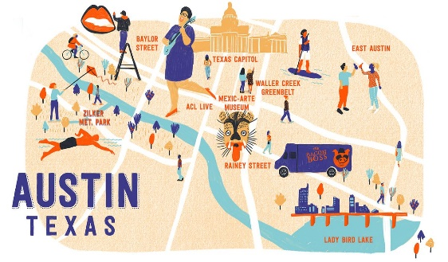

**(b)** extract Latitude & Longitude co-ordinates

**(c)** drop unnecessary columns

to create a concise dataframe ***df_austin*** which has 65 rows and 4 columns.

Here is a Leaflet map using the Folium library of the centroid positions of Austin neighborhoods.

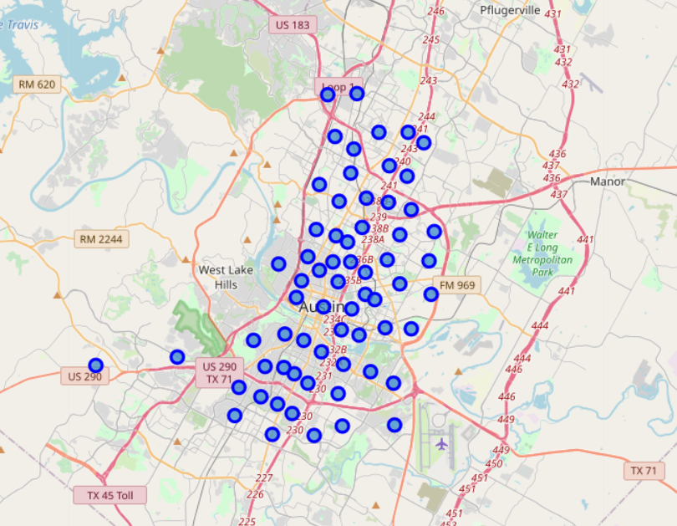

**Exploring the first neighborhood:**

The first neighborhood in our neighborhood dataframe is ***“Allandale”***. By using the explore endpoint, latitude and longitude coordinates of the centroid along with my credentials, a regular API call was made to Foursquare to collect a list of maximum 100 popular spots around 1000m of Allandale. The call returned 38 locations which was put in the following dataframe ***(nearby_venues).***

The top 10 rows of the dataframe is shown here:

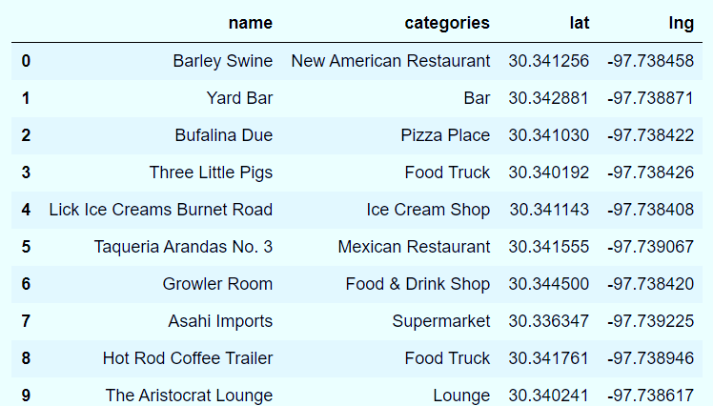

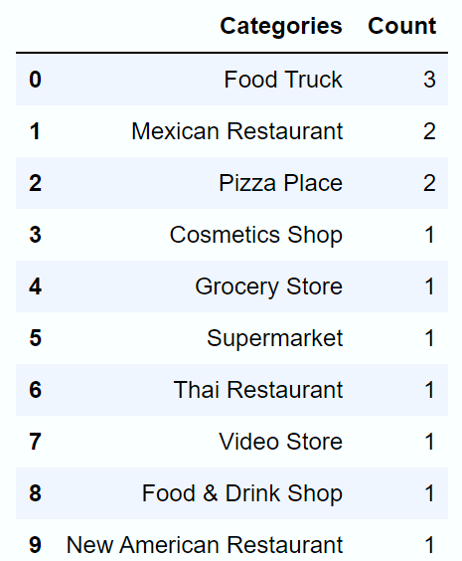

### In Allandale, the most popular categories are “Food Trucks” followed by “Mexican Restaurants” and “Pizza parlors”.

**Exploring all the neighborhoods:**

Following the above procedure, we can now explore all the neighborhoods in Austin. The resulting dataframe (***austin_venues***) has 3234 rows and 5 columns. The first 10 rows of ***austin_venues*** are as follows: 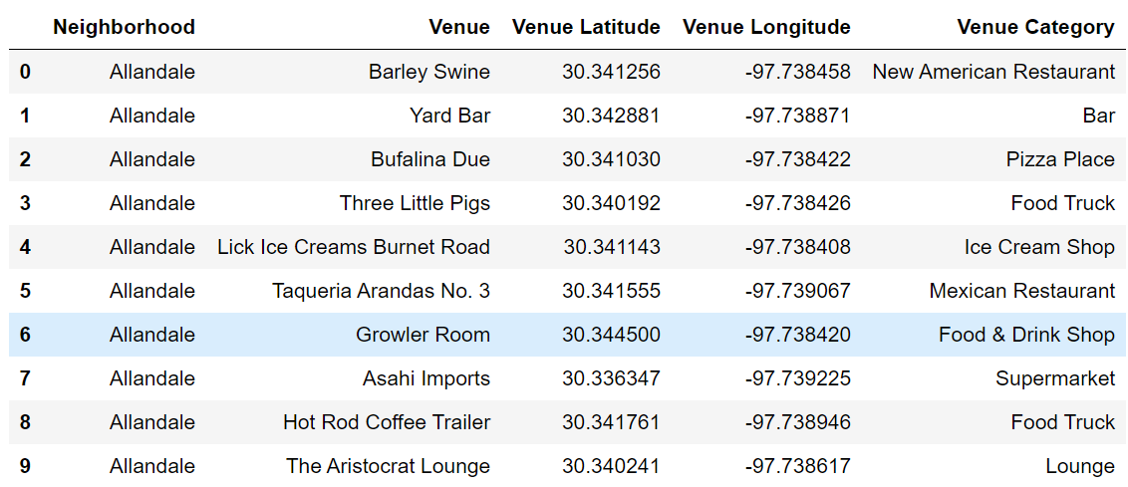

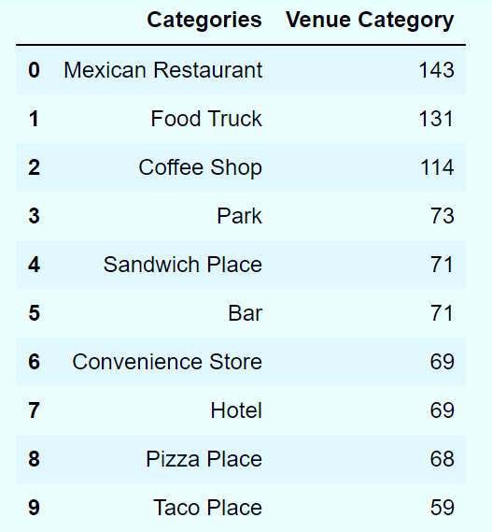

By counting how many times a particular category appears in Austin neighborhood, we can see that the most popular categories are “Mexican Restaurants” followed by “Food Trucks”.

Austin has the fastest-growing food truck industry in the United States, and the second most food trucks per capita in the nation

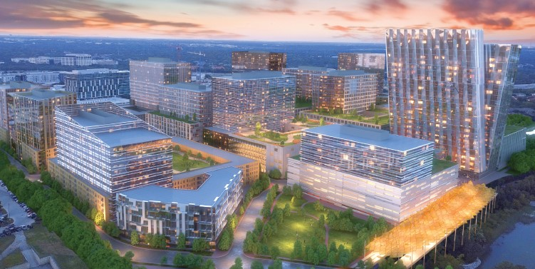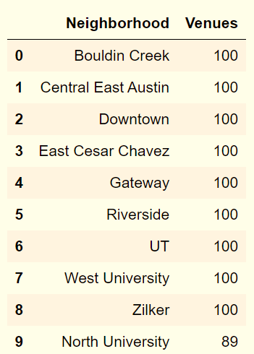Let’s see which neighborhoods returned largest number of venues:

### Austin's second downtown is taking shape in the Gateway Neighborhood, which returned large number of venues along with other neighborhoods in Central Austin



There are 319 unique categories of venues in the ***austin_venues*** dataframe.

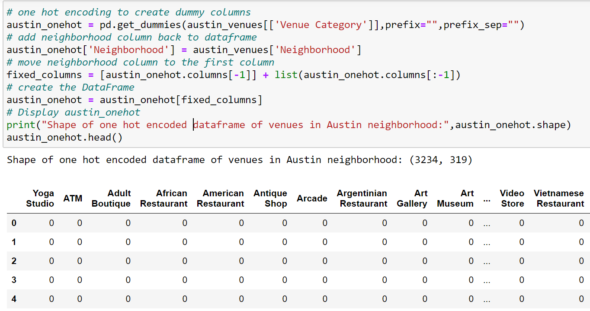**One hot encoding** is a representation of categorical variables as binary vectors. The following code splits the column containing categorical features to 319 columns – each column contains “0” or “1”.

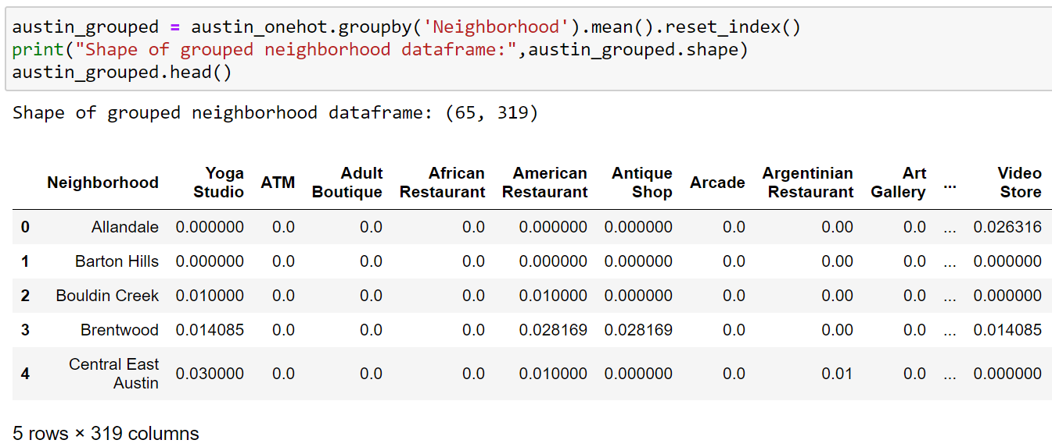Let’s group the one hot encoded dataframe by neighborhood and by the mean of the frequency of occurrence of each category.

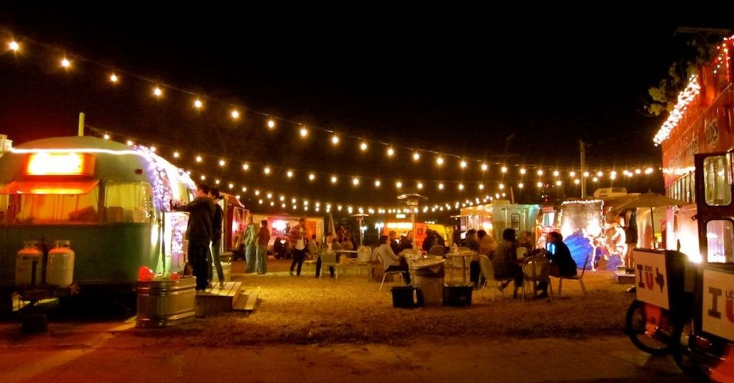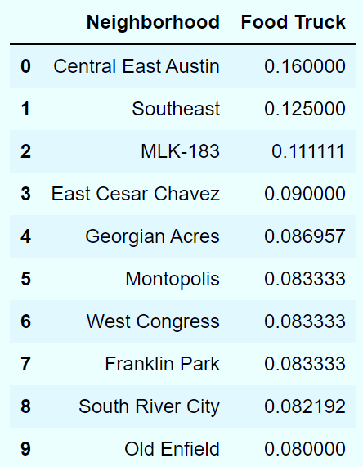We can also check how many food trucks are in each neighborhood:

Central East Austin Food Truck park park

*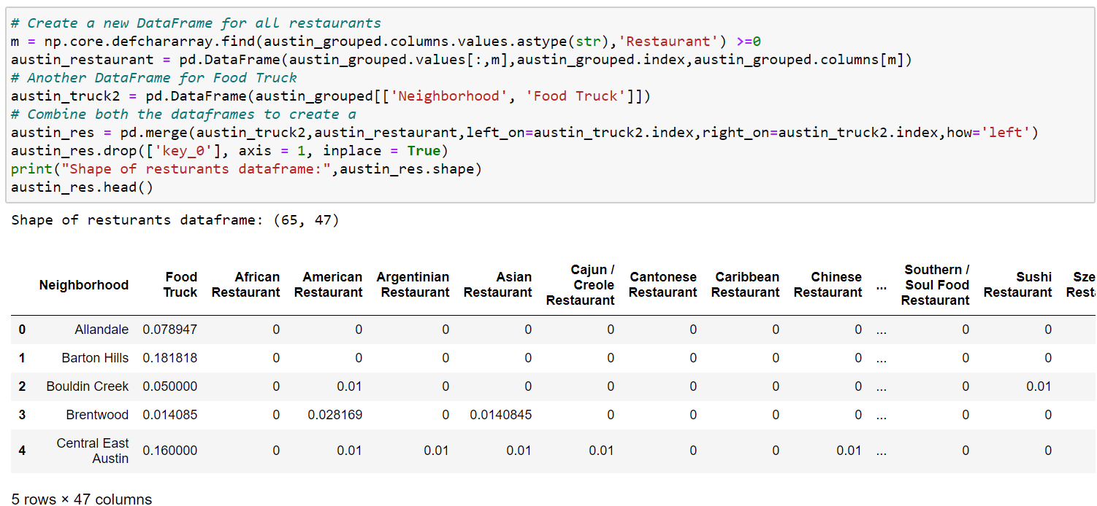Let’s create a new dataframe with Food trucks and all Restaurants*

**Segmenting neighborhoods based on Restaurants & Food Trucks:**

The following code creates a list of top 5 restaurants from each neighborhood.

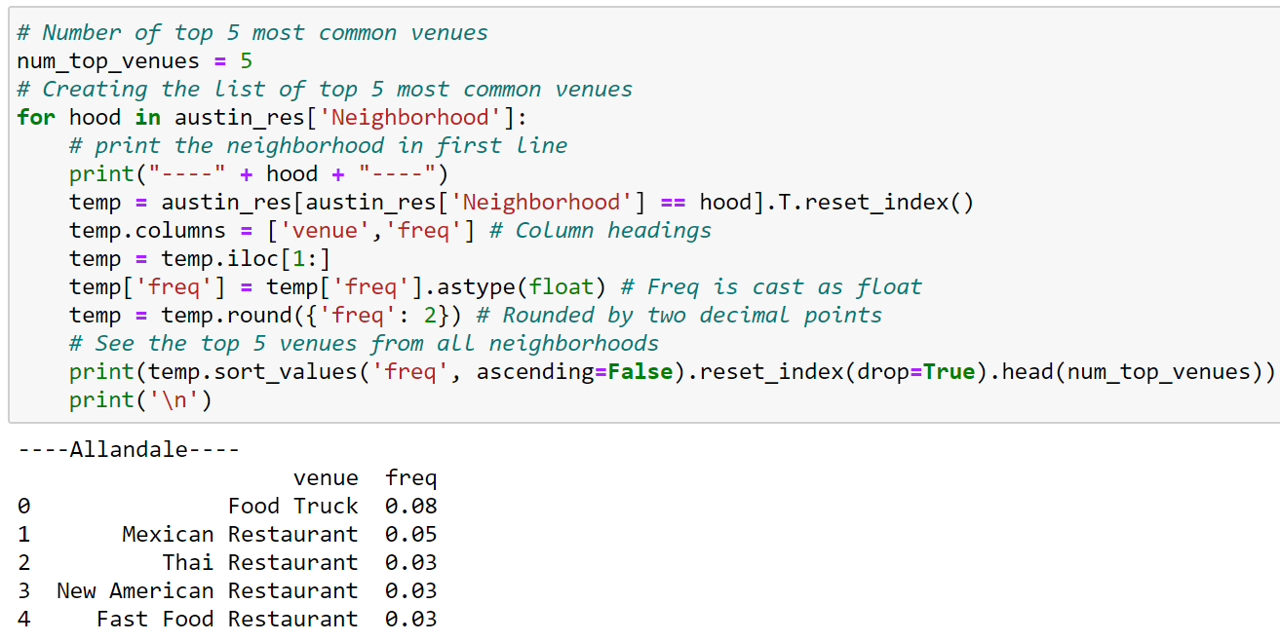

Top venue in Allandale neighborhood is “Food Truck” followed by Mexican, Thai, New American and Fast Food restaurants

The top 10 restaurants from each neighborhood is added to a dataframe (*neighborhood_res_sorted*). Dataframe *neighborhood_res_sorted* has 65 rows and 11 columns. Here are the 1st five rows:

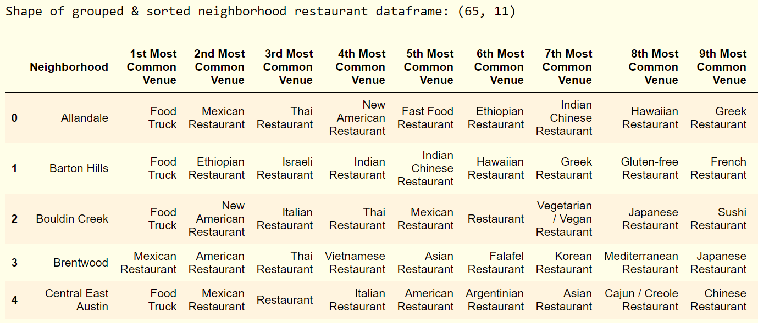

Now, we have two data frames related to food service businesses in Austin:

* *austin_res,* hot-encoded dataframe which shall be used for predictive analysis
* *neighborhood_res_sorted,* dataframe segmented by 10 most common restaurants in each neighborhood.

**k-Means Clustering of neighborhoods based on Restaurants & Food Trucks:**

In cluster analysis, the elbow method is used to determine the number of clusters in a data set. The ***kElbowVisualizer*** implements the ***“elbow”*** method to select the optimal number of clusters by fitting the model with a range of values for K (number of clusters). ***“elbow”,*** which is the point of inflection on the relationship between distortion score and number of clusters, is a good indication that the underlying model fits best at that point.

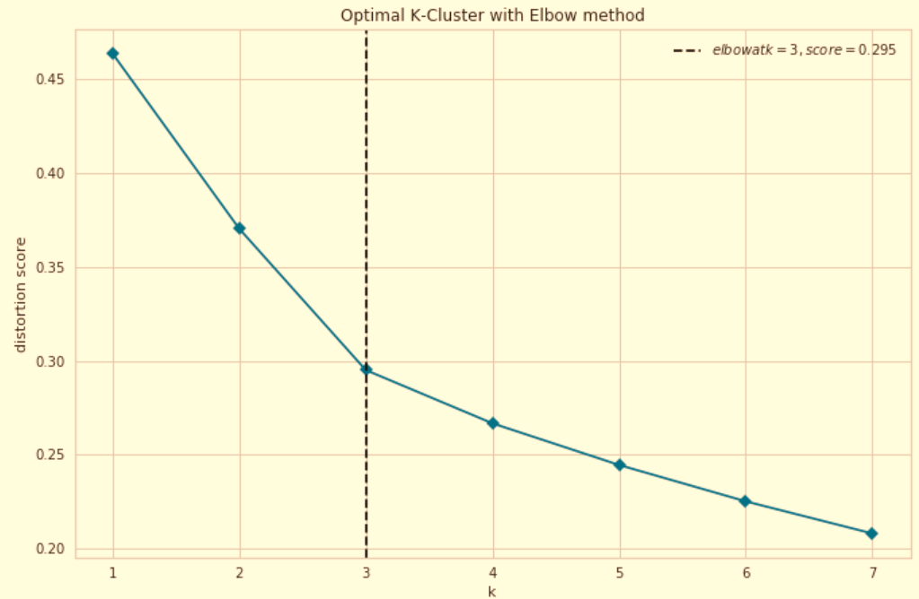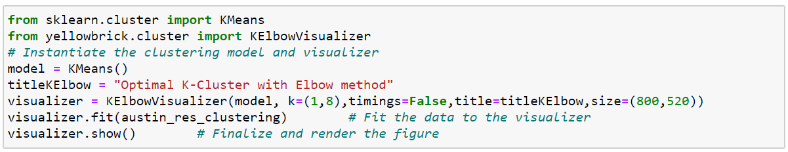

“elbow” analysis shows that there are 3 clusters in this dataset

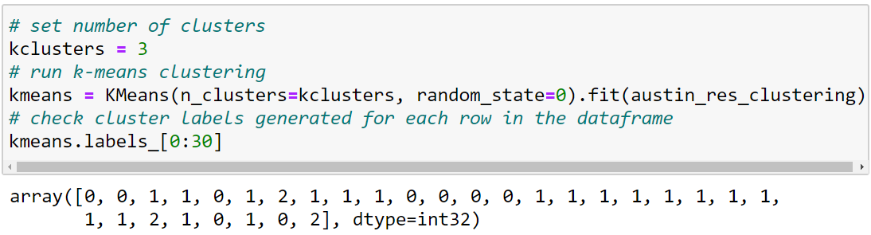

Using the hot-encoded dataframe, we have cluster labels from each neighborhood. Let’s merge the labels with the segmented dataframe (*neighborhood_res_sorted*) to find the ten top restaurants for each cluster.

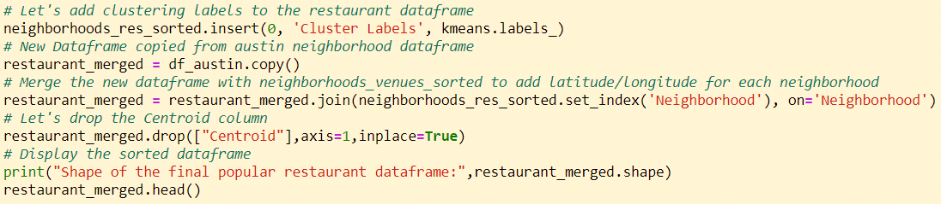

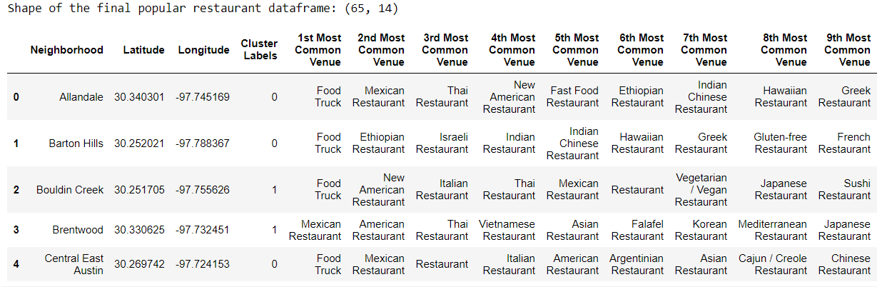

Visualizing the clusters:

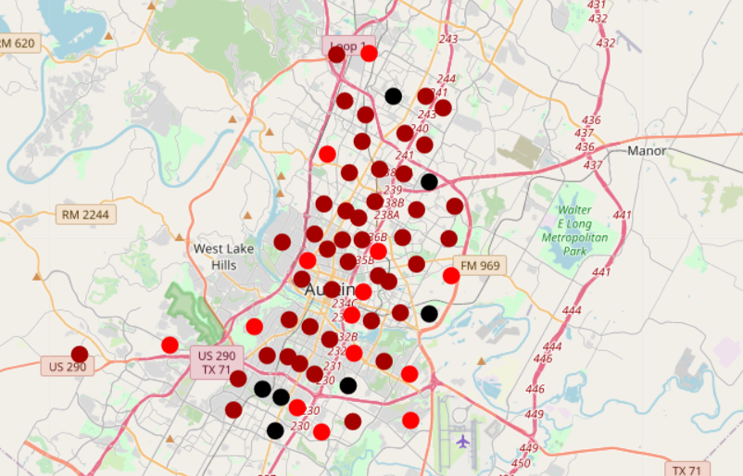

Markers: (a) Black: Cluster #2; (b) Magenta: Cluster #1; (c) Red: Cluster #0

Characteristic of each cluster:

Let’s inspect the most common venue from the 1st cluster:

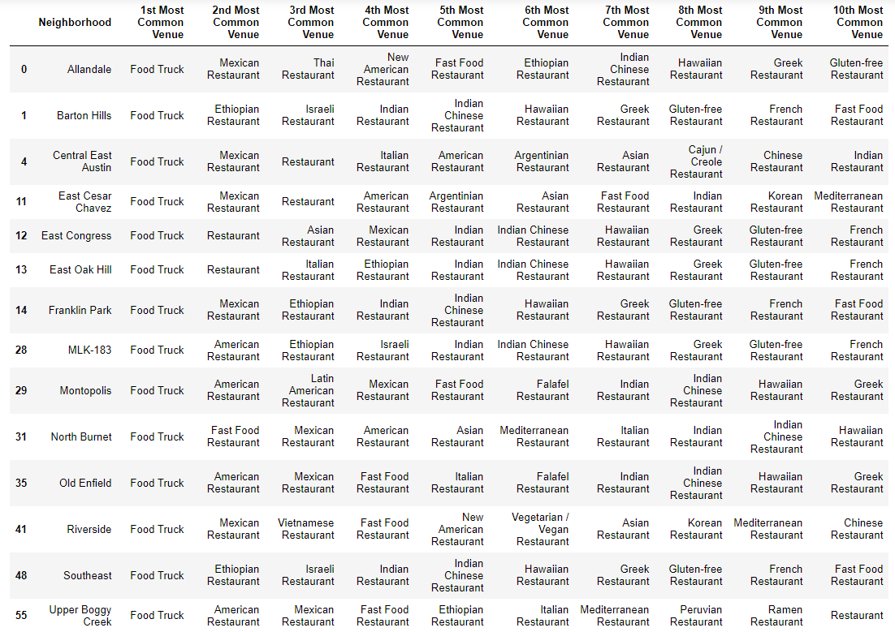

Most common venue from the 2nd cluster is as follows:

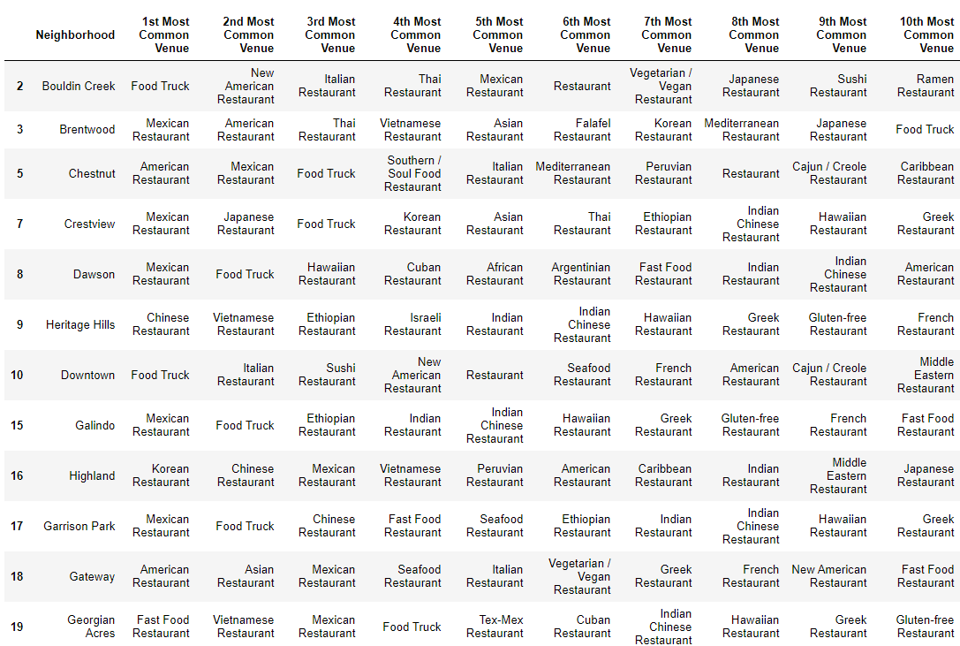

Here are the most common venues from the 3rd cluster:

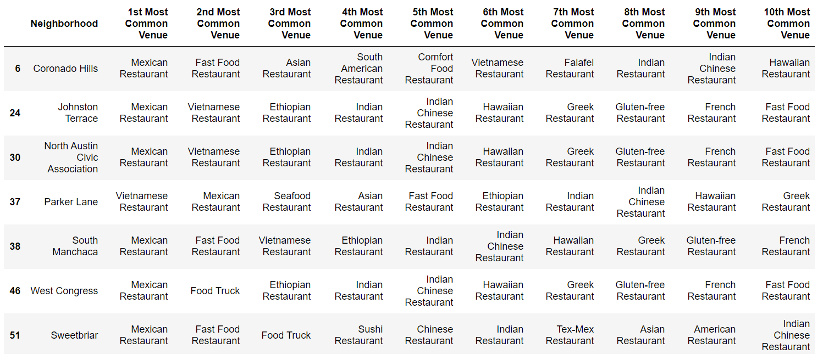

Conclusion of Neighborhood clustering analysis:

The three unique clusters of food establishments in Austin neighborhoods are as follows:

* Cluster #1 comprises of 14 neighborhoods where 1st most common venue is Food Truck. From the leaflet map, we see that this cluster comprises of neighborhoods from East and South-East.
* Cluster #2 comprises of 44 neighborhoods where multicuisine restaurants are 1st most common venues. This cluster comprises of most of the neighborhoods along the North-South corridor.
* Cluster #3 comprises of 7 neighborhoods where 1st most common venue is Mexican Restaurant. 5 members of this cluster are neighborhoods in South Austin.

Now that we know where most of the food establishments are clustered, we would like to narrow our search for Indian restaurants with respect to Indian population in Austin. Since the customer base for Mr. Lohanathan’s new venture will be primarily Indians, he would like to know which neighborhoods have a larger share of Asian Indians and if that neighborhood is under-served as far as Indian Restaurants are concerned. For the next part of the project, we shall analyze the demographic data from the U.S. Census Bureau (which provides population count of Asian Indians) along with the demographic data available in City of Austin data portal. We shall use Foursquare API to find the number of Indian Restaurants in each census tract and explore if there is any correlation between the Asian Indian population and Indian Restaurant in each census tract.

# Visualizing the Asian- Indian Population in Austin:

A dataframe (***df_census_tracts***) was created by reading a GeoJson file from the City of Austin data portal followed by data cleanup (dropping un-necessary columns and renaming columns). Here is the head of the dataframe:

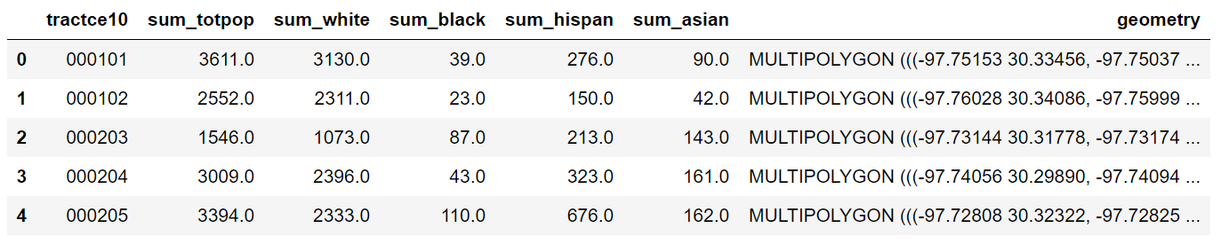

A Bokeh map showing the boundaries for 350 census tracts in the dataframe: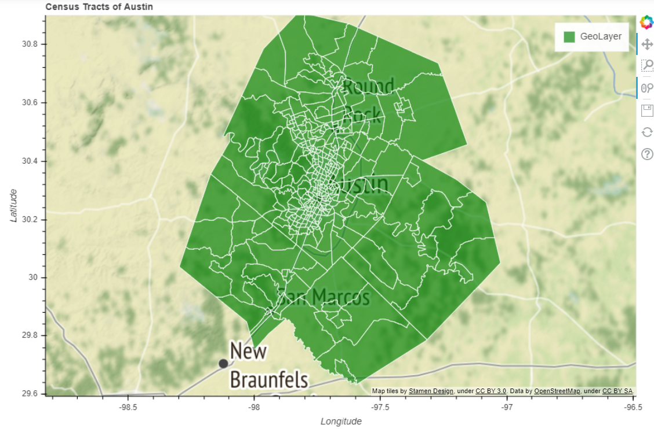

Our next steps would be to find the centroids of these census tracts, extract Latitude and Longitude co-ordinates so that we can visualize the centroids in a leaflet map built with Folium library.

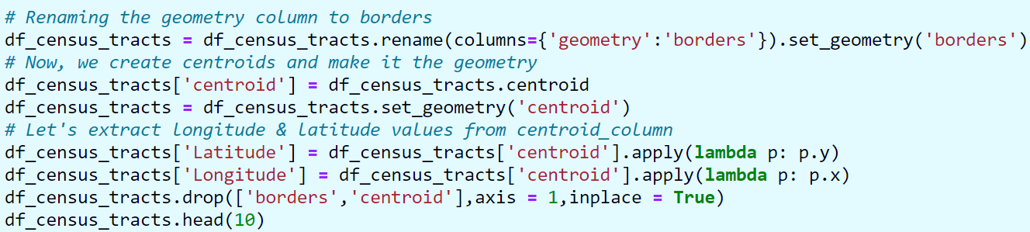

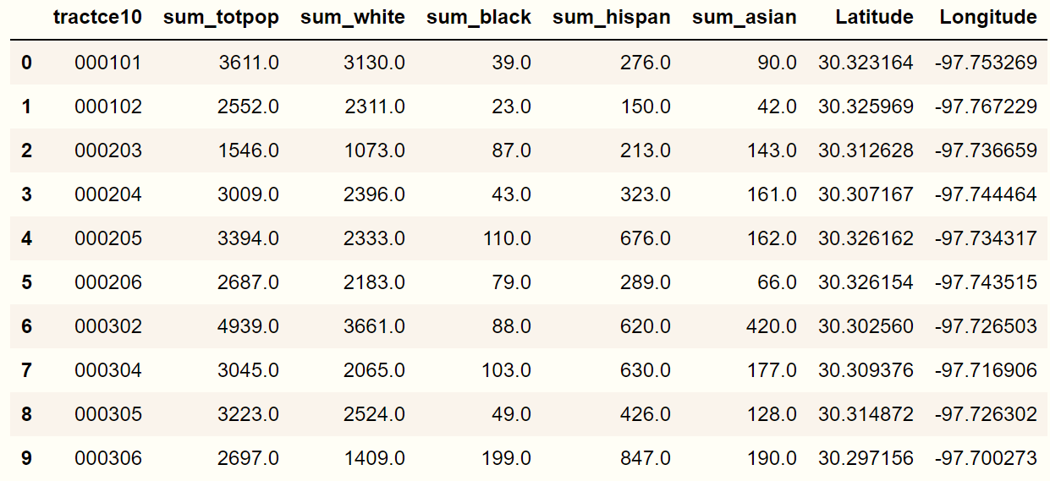

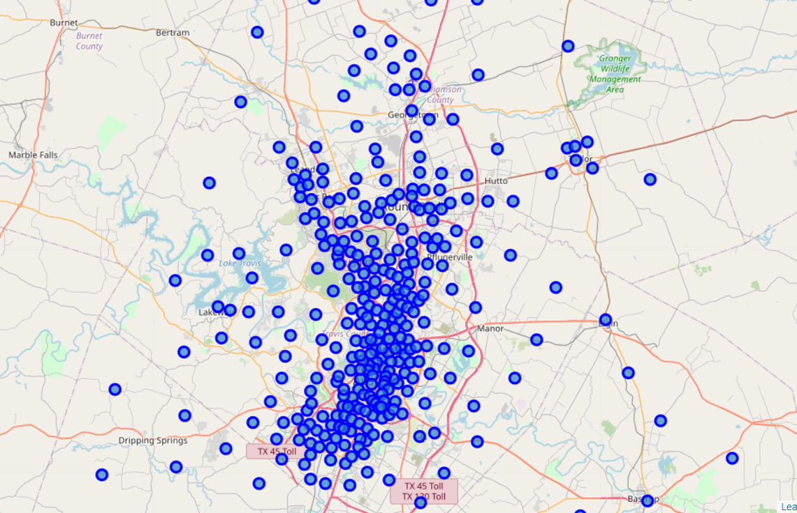

Centroid location of Census Tracts

U.S Census Data for Travis County:

For our demography analysis, we selected Travis County whose county seat is Austin. With population more than 1.3 million, Travis County is the fifth-most populous county in Texas. Travis county census tract data for Asian Indians, is downloaded from U.S. Census Bureau and loaded in dataframe (*df_asian_indian*). Here is the head of the dataframe: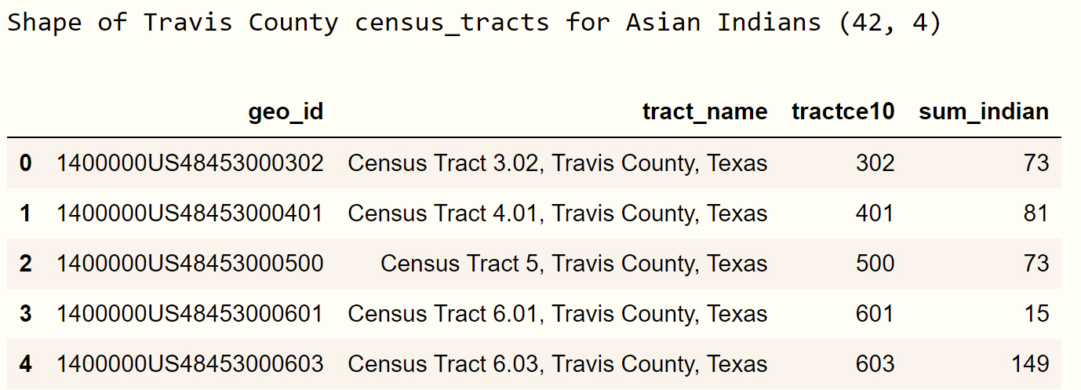

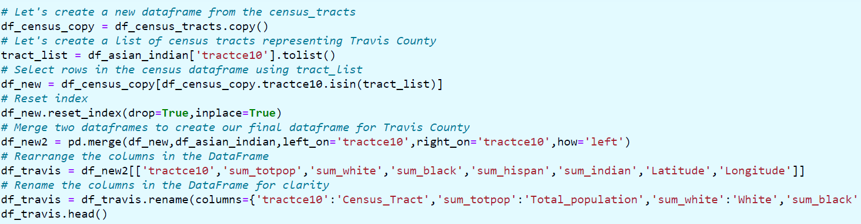Since the City of Austin demographic dataframe (*df_census_tract*) did not have the population count of Asian Indians, we merged the two data-frames (*df_census_tract* and *df_asian_indian*) to create Travis County population dataframe (*df_travis*)

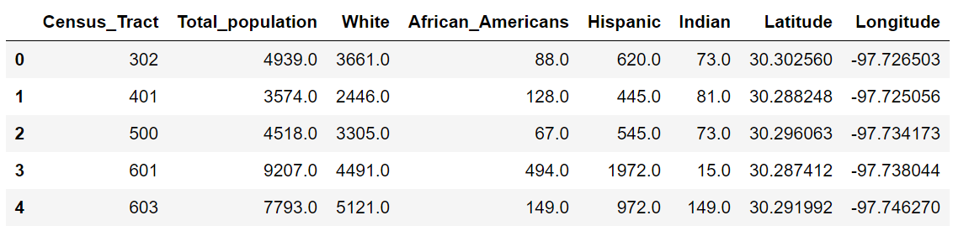

Centroids of Census tracts in Travis County:

Let us visualize the centroids of the census tracts in Travis County in a Leaflet map built using the Folium library.

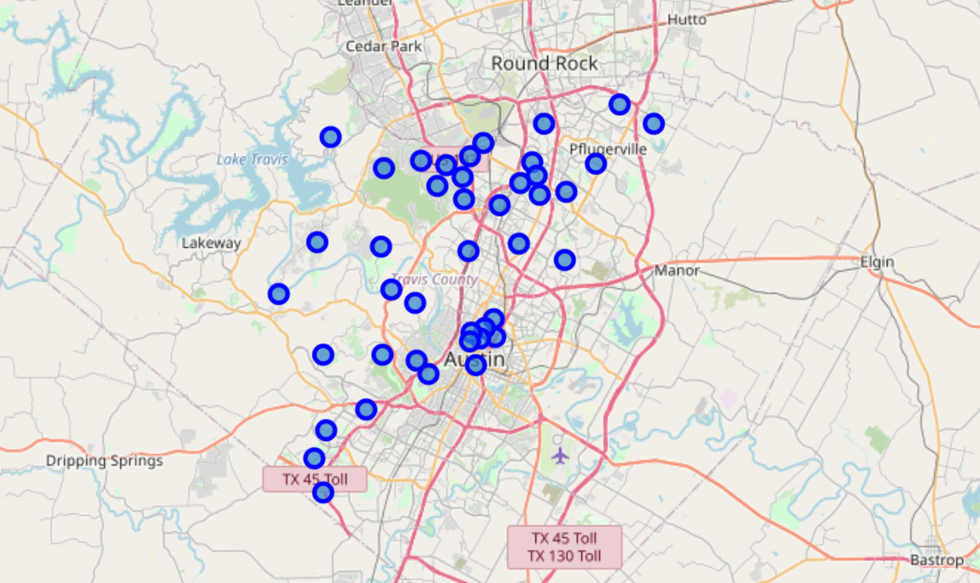

**Exploring Travis County census tracts using Foursquare API:** By using the explore endpoint, centroid latitude and longitude coordinates along with my credentials, a regular API call was made to Foursquare to explore popular spots around 1000m of each census tract. The call returned 1315 venues which was put in the dataframe ***(travis_venues)*** along with Census Tract number and GPS coordinates***.***

The top 10 rows of ***travis_venues*** are shown below:

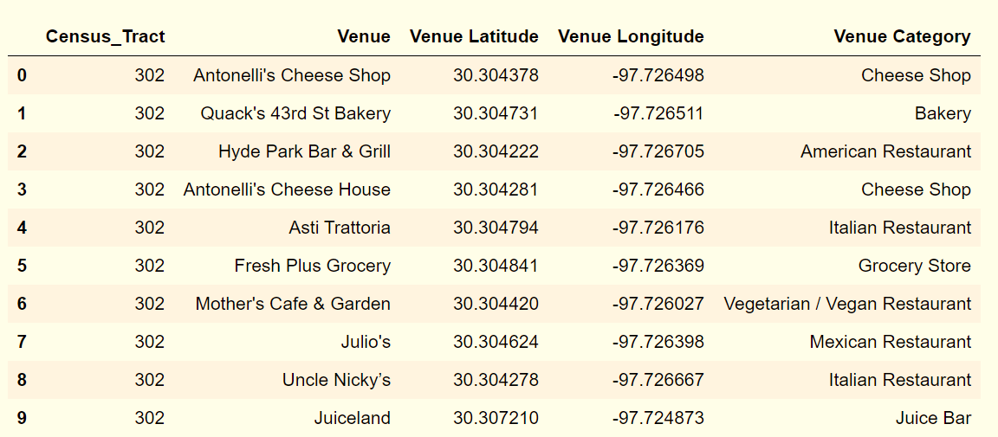

### Which venue categories are most popular in Travis County?

As shown in the adjacent table, *sandwich places are most popular in Travis County* followed by coffee shops. Fast food restaurants, Pizza place and Food trucks are more popular than any dine-in restaurants

### Which Census Tracts returned the largest number of venues?

As shown in the table below, ***Census Tract #s 1100, 601, 604 and 603*** returned the highest number of venues

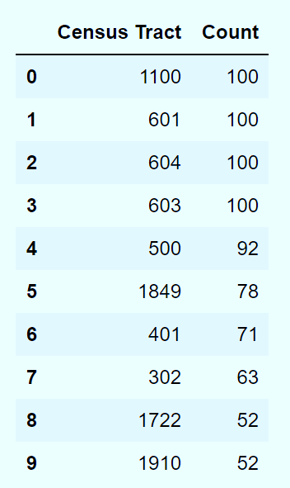

### *Census tract # 1100 represents downtown Austin and returned one of the largest number of venues*

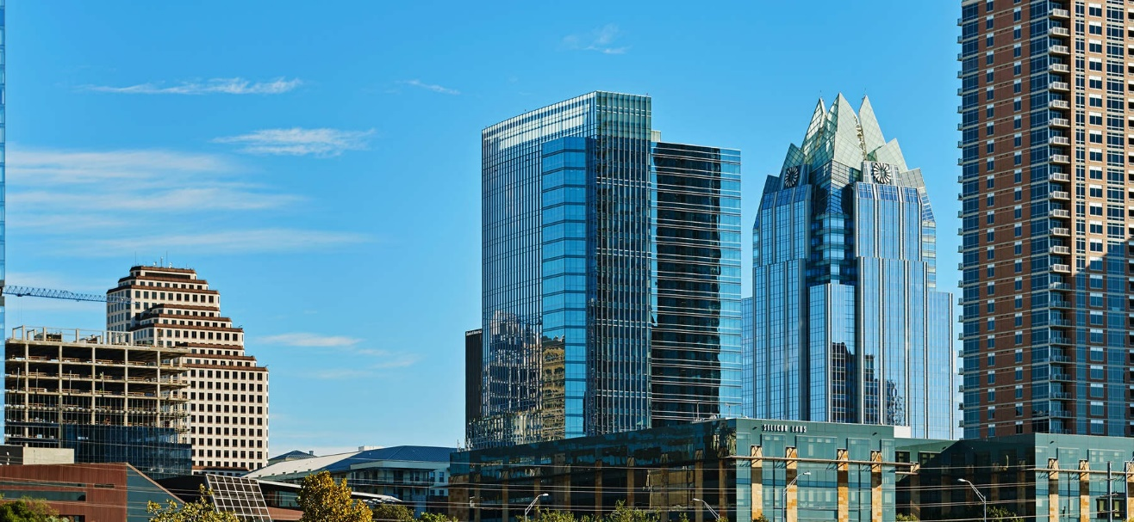

Census tract # 1100 (Downtown Austin)

How many unique venue categories in Travis County?

*Indian Restaurant is one among 243 unique categories*.

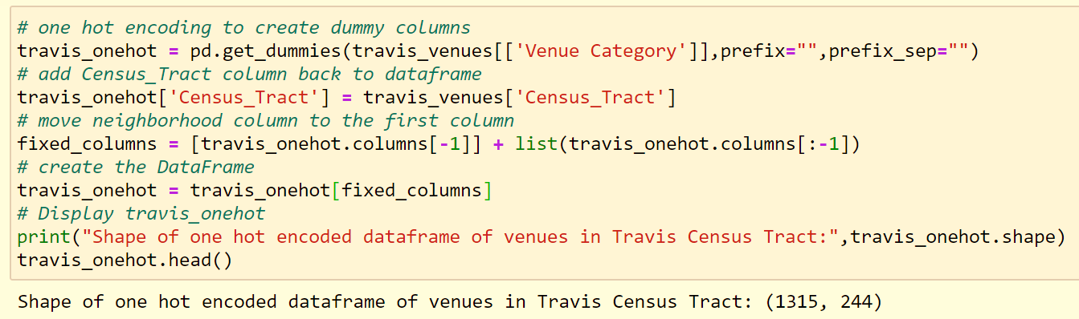One Hot Coding to create dummy variables:

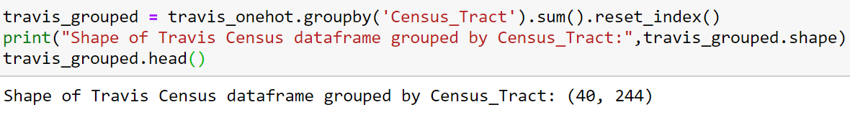Now we group by Census Tracts the total occurrence of each category:

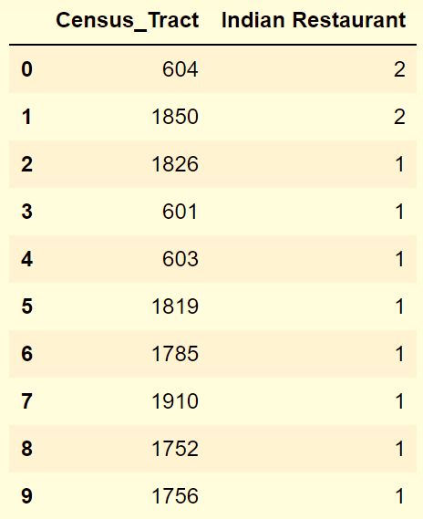Let’s check how many Indian Restaurants are in each Census tract:

The dataframe travis_new contains the number of Indian Restaurants for each Census Tract arranged in descending order. Here are some observations:

1. There are 12 Indian restaurants in Travis County
2. These restaurants are spread over 9 Census tracts
3. Census Tract # 1850 and # 604 returned two restaurants each

Let’s check the Asian Indian population in these Census Tracts:

This will help us answer the following questions:

1. ***Is there is a correlation between Asian Indian population and the number of Indian Restaurants?***
2. ***Is there a census tract where a new Indian Restaurant can cater to an underserved community of Asian Indians ?***

**Let’s create a dataframe of Asian Indian population that has atleast one Indian Restaurant in the Census Tract:**

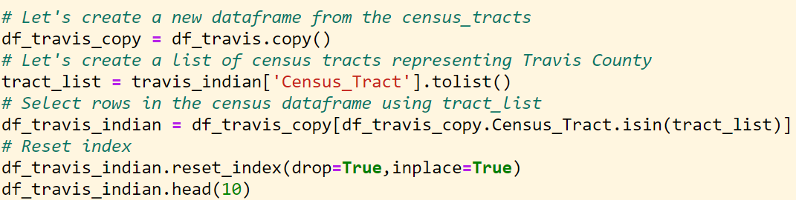

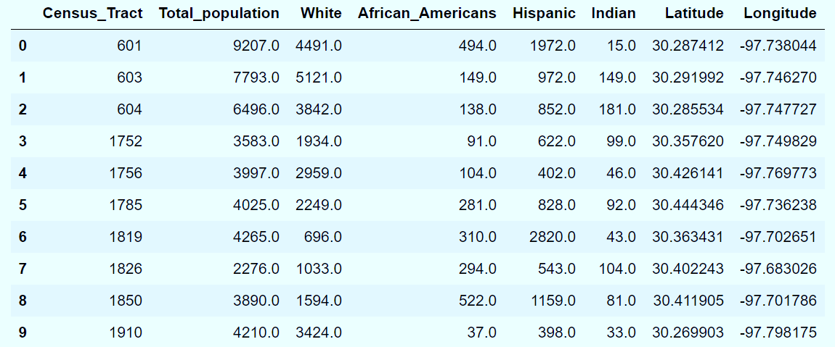

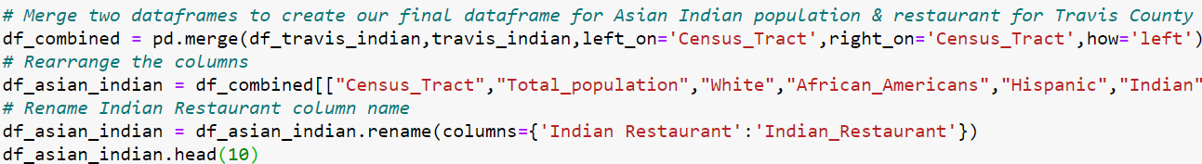**Merging this dataframe with Indian Restaurant dataframe:**

Now we have our final dataframe (***df_asian_indian***) which contains the ***Census_Tract***, ***Total population, White population, African American population, Hispanic population, Indian population, Indian restaurants*** and ***GPS co-ordinates***. Here are the 1st ten rows of the dataframe:

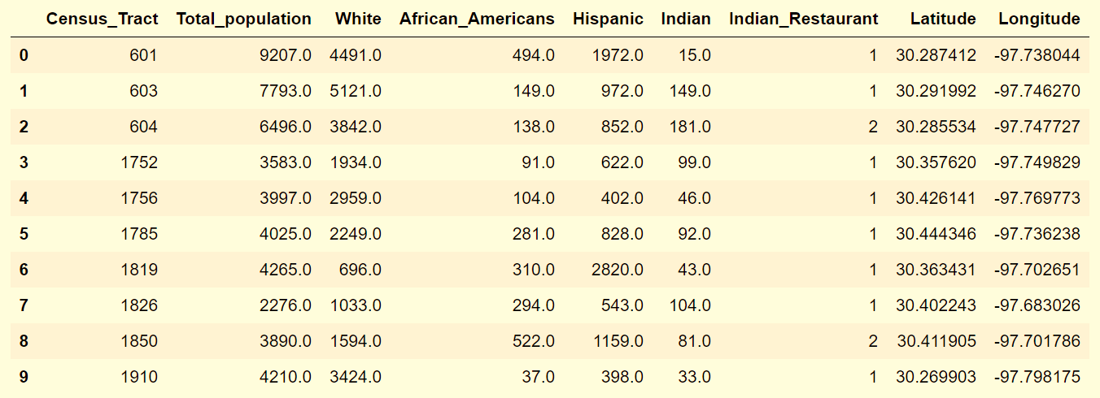

Centroids of Census tracts with atleast one Indian Restaurant:

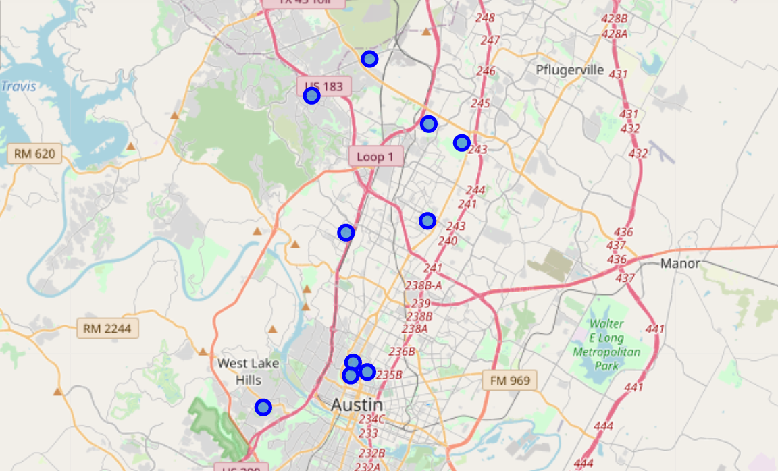

Studying the above dataframe (*df_asian_indian*), we see that Census_Tract # 604 has the largest Asian Indian population and has access to two Indian Restaurants. But the Census_Tract # 603 with second largest Indian population has only one Indian Restaurant (one less restaurant than Census_Tract # 1850, which has 46% less population). *Census_Tract # 603* is an underserved area – where an Indian mobile restaurant would find a large number of customers.

Looking for correlation between Indian Population & the other columns in the dataframe:

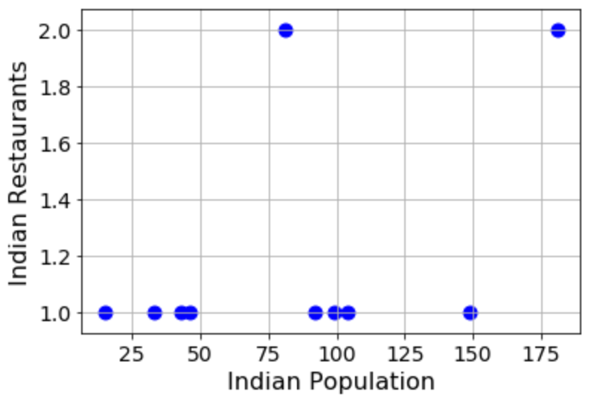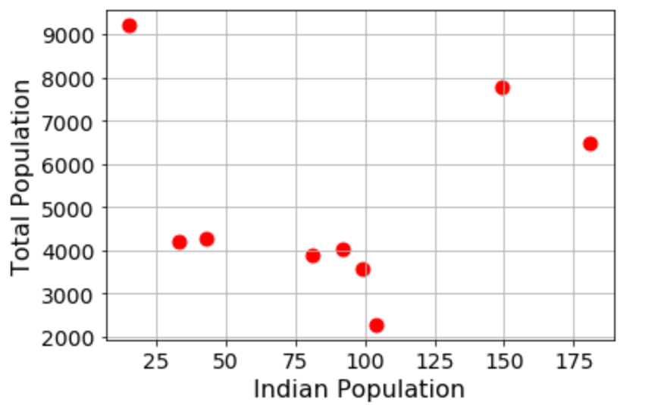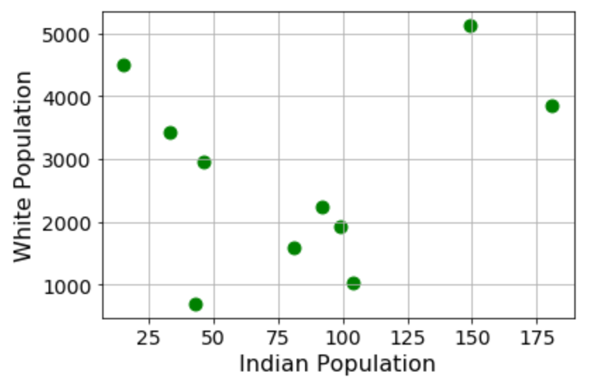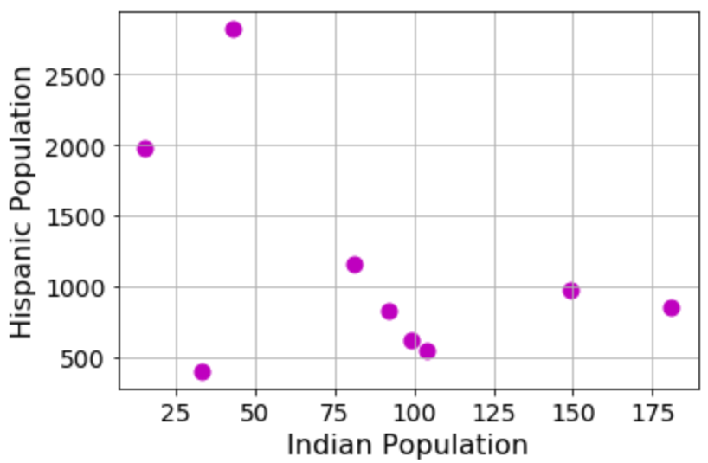

From the scatter plots shown above, we see that there *doesn’t exist any correlation* between the Asian Indian population and the other columns in our final dataframe.

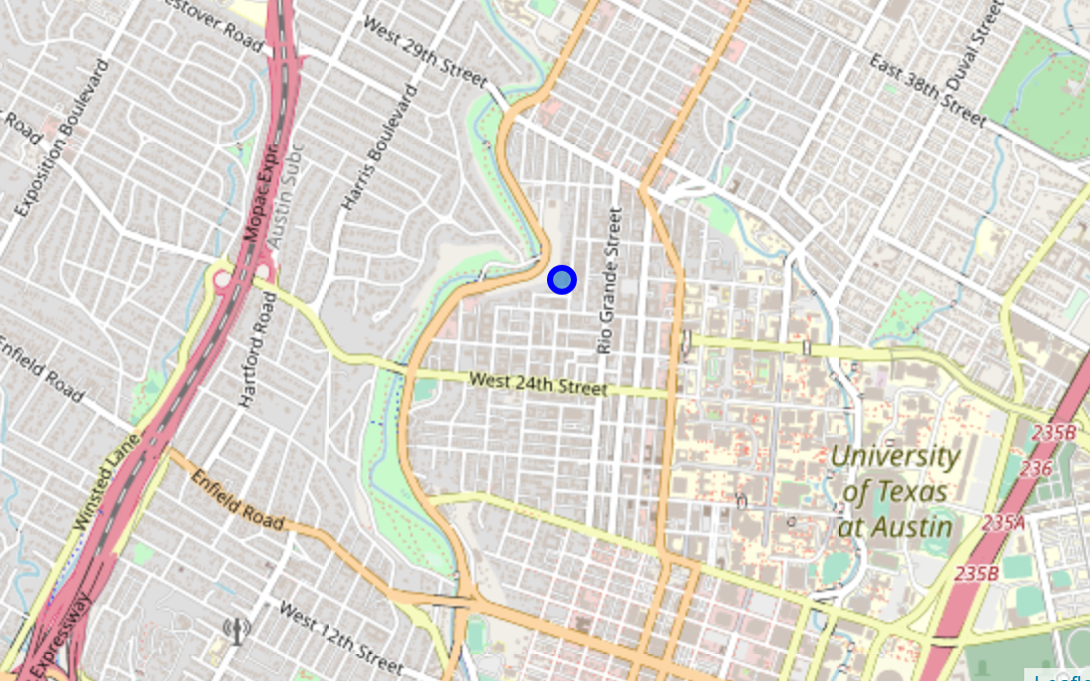We have identified *Census_Tract # 603* as an underserved market for restaurant business. The location of this tract is shown in the adjacent Leaflet map. Interestingly, this tract falls in *Cluster #1* *(magenta marker)* of our neighborhood clustering. This cluster is far away from *“food truck”* cluster and *“mexican restaurant”* cluster. Thus, we are confident that this location would provide a unique business opportunity for Mr. Lohanathan to start his mobile restaurant business.

Location of Tract # 603

# Conclusion:

We started this project with a mission to find a profitable location to start a mobile food business catering to the Asian Indian population in Austin, Texas. Using k-means clustering method we created three unique clusters of restaurants and food trucks in our Austin neighborhood. Analyzing the Census data from City of Austin data portal and U.S. Census Bureau we pin-pointed a tract where a mobile restaurant can serve an underserved market. Thus, we are confident that ***Census Tract # 603 within Cluster # 1*** is the optimum location for starting a mobile food business catering to the underserved Asian Indian population.

# *PostScript:* *At the end of the project, I decided to call Mr. Lohanathan to convey my findings.*

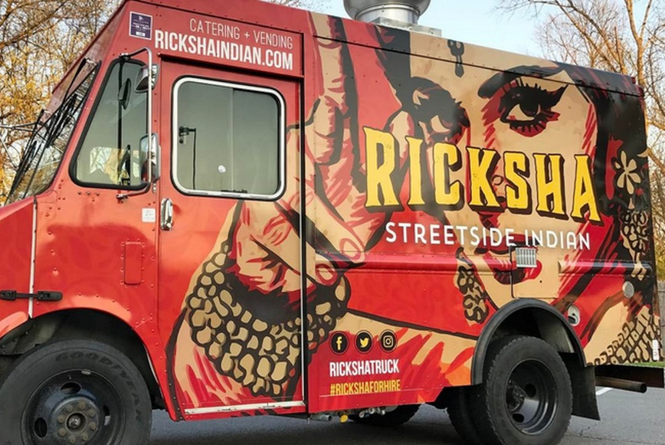***Me:*** *I know the right place where you should move your mobile business. In normal times, I would have suggested Cluster # 0 where all the food trucks are located. But during lockdown, you don’t expect your customers to visit those venues. Cluster # 2 is not suitable either because it is a cluster of Mexican Restaurants. So,* ***Cluster #1 is the best option****. But I have found a* ***particular tract (tract # 603)*** *in this cluster where there is a large number of Asian Indian population in an underserved market.*

***LN:*** *Thank you so much for your data driven analysis. Is there anything more you would like to do in this project?*

***Me:*** *Now that I have the analysis done for Travis county****, I would very much like to see the neighboring counties like Williamson and Round Rock*** *where companies like Apple, Amazon, Facebook are setting up offices. This would result in large increase in Asian Indians in those communities.*

*Also****, I would like to get feedback from you****, so that I can refine my model and maybe find another opportune cluster.*

***LN:*** *Of course, my friend. By targeting locations based on data, we shall bring a paradigm shift in the mobile restaurant business in Austin.*